Be a Saint

Plan a campaign to coincide with All Saints Day or another feast day that is meaningful for your church. Set a goal for an achievable number of givers, and offer an incentive to families who make any online gift during this timeframe—this group can include members already using ParishSOFT Giving.

Prize Ideas
- Family dinner at a local restaurant
- Dinner/movie package
- Overnight stay at a local getaway

Local businesses in the area are usually happy to donate a prize in exchange for the publicity you’ll give them. You could have small gifts to all participants or have a drawing to award fewer, higher value prizes.

Promotion
- Posters: Print posters for your gathering spaces and bulletin boards in classrooms, church office, and worship area.
- Invitations: Send invitations via mail or email.
- Pre-Campaign Announcement: Do a pre-campaign announcement—any form you like—to get people used to the idea.
- On-Date Announcement: Kick off your campaign with energetic announcements on a date you choose as your “Be a Saint Sunday.”
- Be a Saint Series: Have a series of “Be a Saint Sundays” during your campaign, and offer test drive sessions after those services during “Be a Saint Coffee Hour.”

Tracking
Check your church administrator reports in the ParishSOFT Giving system to see who your online givers are and what new gifts they have made.

Let members know the results of your campaign at various phases.

For example, if your campaign will run for three months, you might announce, “As of Mon. DD, XX families are participating in our Be a Saint program by signing up for ParishSOFT Giving. Together they’ve already donated more than $X,000. Help us meet our goal and you could be the winner of [name prize].”

Update your results in the Be a Saint campaign every two weeks from the pulpit, weekly in the bulletin and on your website, and in each issue of your church newsletter.

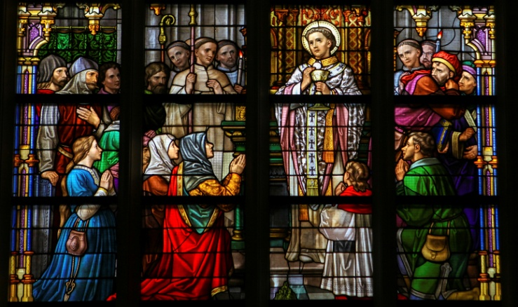

Tailored for Your Church
- Pick your “Be a Saint Sunday.”
  - Is there a saint who is particularly meaningful for your church?
  - Will the time of year work with your selected holiday, or should you make adjustments?
- Determine who qualifies.
  - How many members do you have using ParishSOFT Giving? Should they qualify to participate, or should these be for new users?
  - Remember that even those who have registered should still be encouraged to continue using ParishSOFT Giving.

Prize Planning
- Choose your prizes.
  - Contact local businesses.
  - Ask members who have connections, own restaurants, etc.
- Decide how you will determine winners.
  - Does everyone who participates get a prize?
  - If you have fewer prizes, consider a drawing.
  - Should prizes be awarded throughout the campaign or at the very end?
- Decide when/how prizes will be distributed.
  - Announced in service?
  - Notice in the bulletin?
  - Given at a church event?

Promotion Schedule
- Decide which types of promotions you will use.
  - Posters
  - Invitations
  - Pre-campaign announcements
  - On-date announcements
  - Be a Saint series
- Map out a timeline with specific dates so that nothing is missed.
- Make sure you have the necessary resources to execute.

Organize Your Staff
- Thoroughly discuss plans with staff.
  - Who’s in charge of tracking ParishSOFT Giving and getting updated data for the campaign?
  - Who will be the up-front spokesperson?
  - Who is in charge of creating promotional materials?
  - Who will acquire and organize prizes?
- Troubleshoot and brainstorm.
  - Are there any concerns about the campaign?
  - Are there anyways to better tailor it for your parish?

