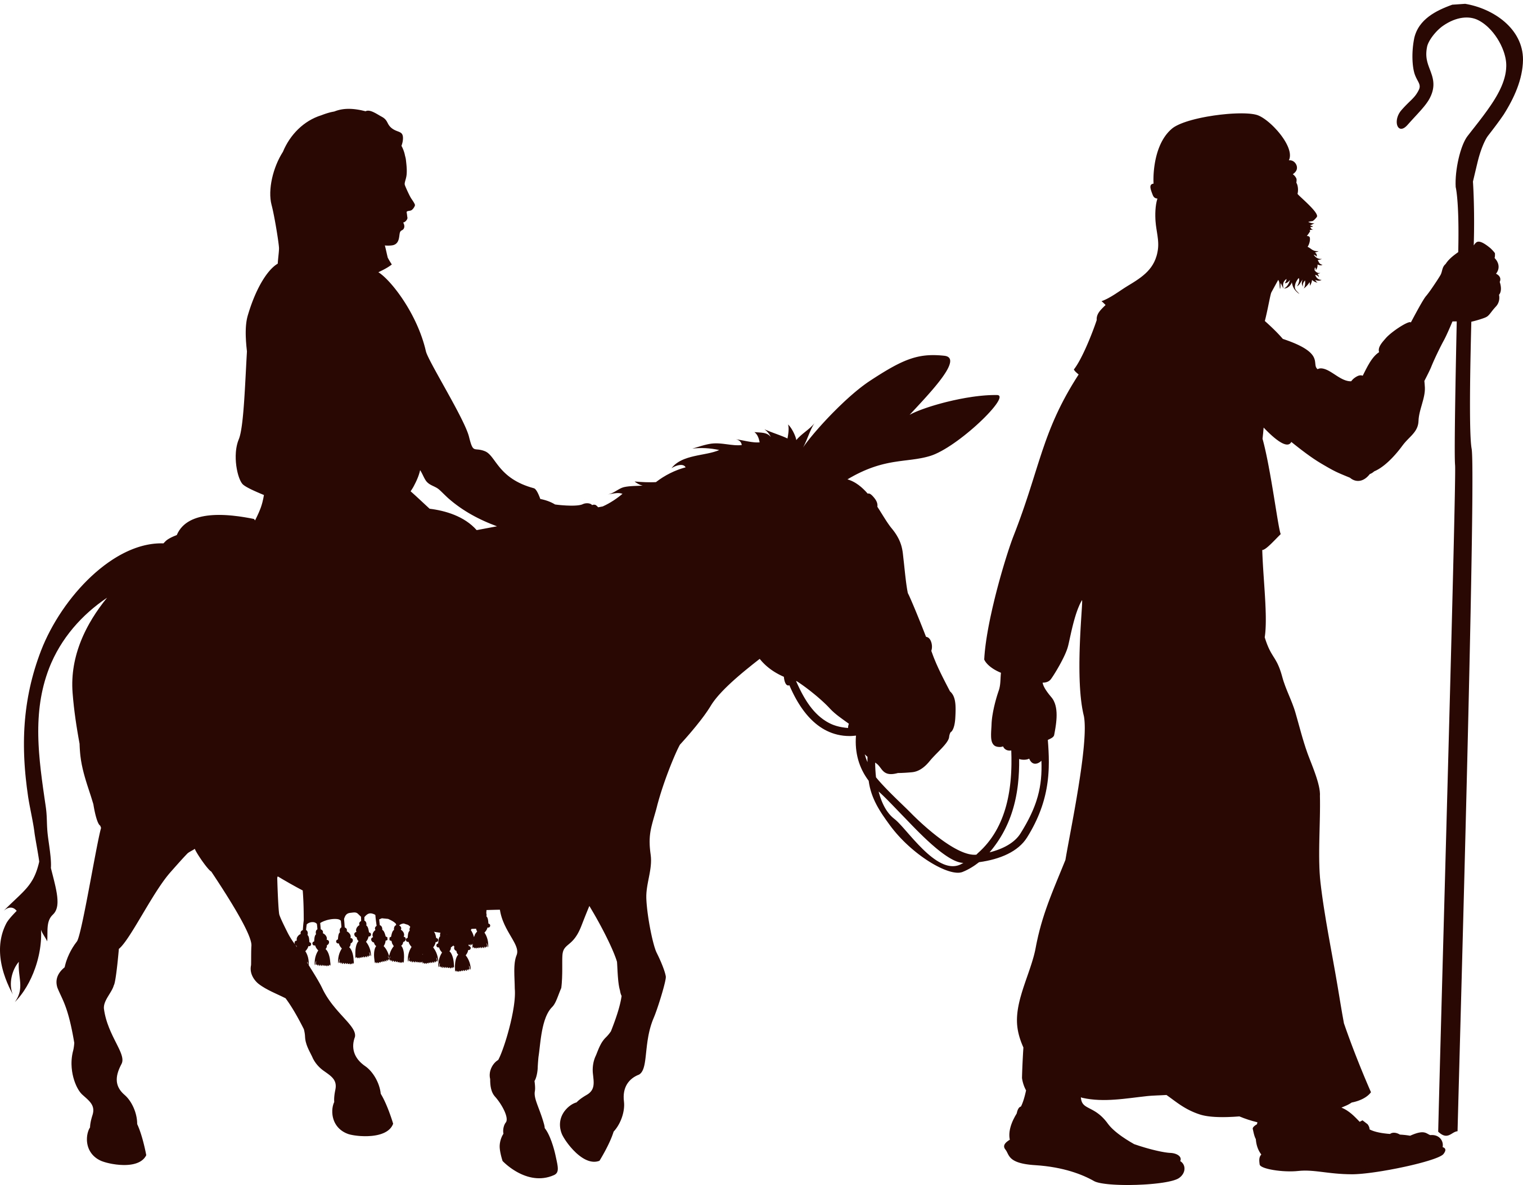

Go to [www.yourchurchwebsite.com](http://www.yourchurchwebsite.com) and look for this button:

**You don’t have to journey by donkey to Bethlehem to be counted…**

Just create a **My Own Church** login, and update your information. It’s really *that* easy!